# Introduction

The game is part of the overarching iSNAP-project; a health intervention focused on increasing health behavior in school children. The meal crusher game will focus on trying to change children’s attitudes towards the importance of a healthy diet in a fun and engaging way. This is done by trying to influence them outside of their awareness; by letting them form positive associations with good foods and behaviours and negative associations with unhealthy foods and behaviours.

The children must form collections of foods of similar colours in a similar fashion as is done in the popular game ‘Candy Crush’. The collections that they form however are not random but they represent food groups. For every combination made the child will get points, which acts as a reward. This will help them form positive associations with the normal foods. Bad influences, represented by for instance icons of smokes, prohibit the user from getting scores and can cost them valuable points. This acts as a punishment and will cause the user to form a negative association with that specific icon. Further details are explained below.

# Game play

## Onboarding

When users open the game they will be presented the game dashboard. The game dashboard features the following items:

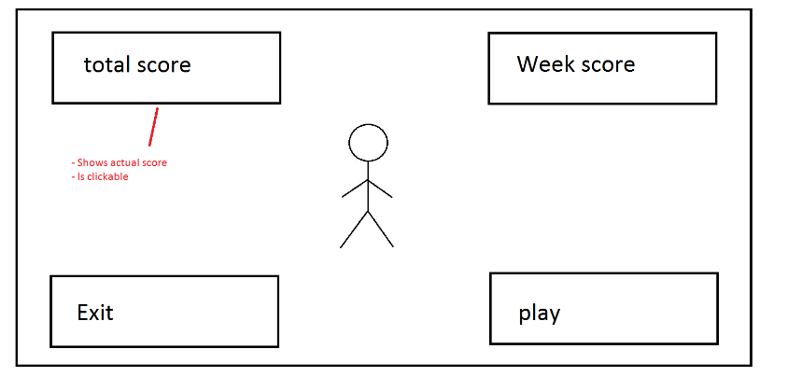

* Week score (upper right corner)
  + Clicking on the week score will open up a new screen displaying the total scores for all the respective weeks
  + The weeks that have not been unlocked yet will be greyed out

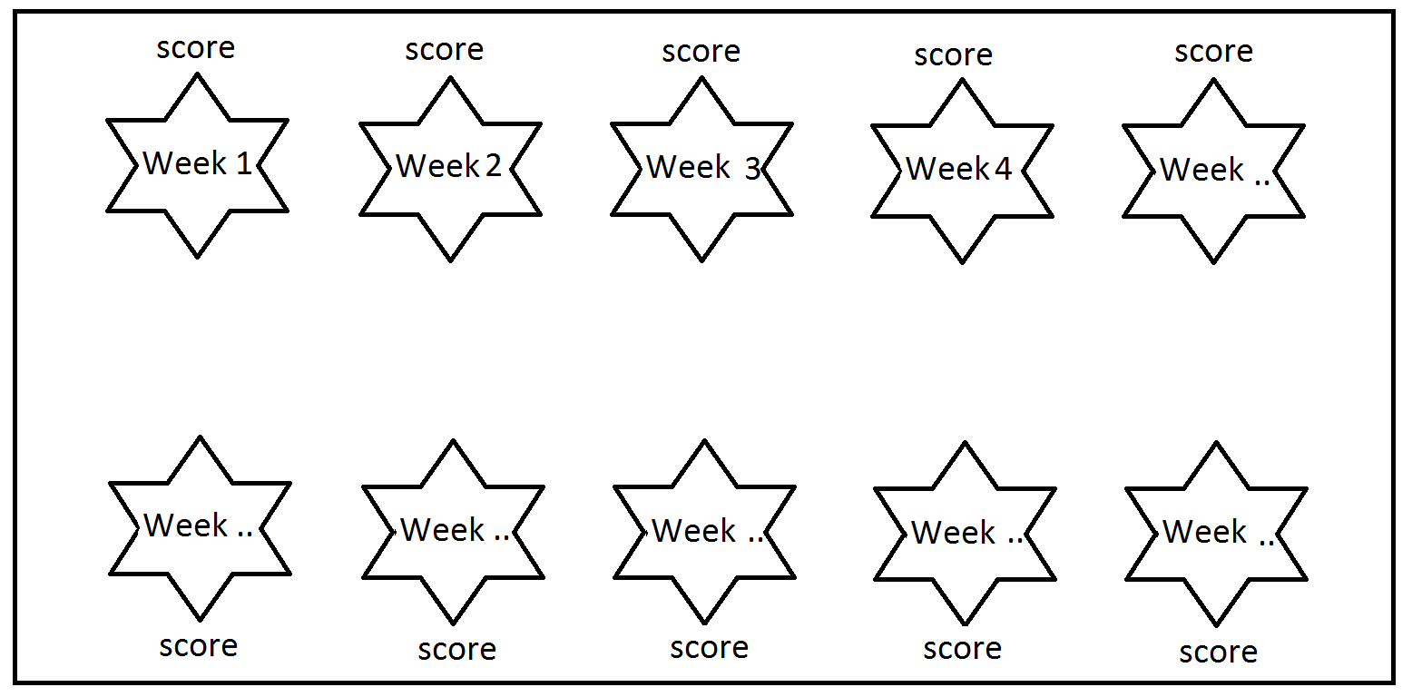

* Total score (upper left corner)
* Avatar (middle of the screen)
  + Avatar should be customizable
    - Variety of races
    - Different genders
* Background
* Play button (lower right corner of screen)
  + The play button will take them to the week score overview
  + The specific week they are at will be highlighted

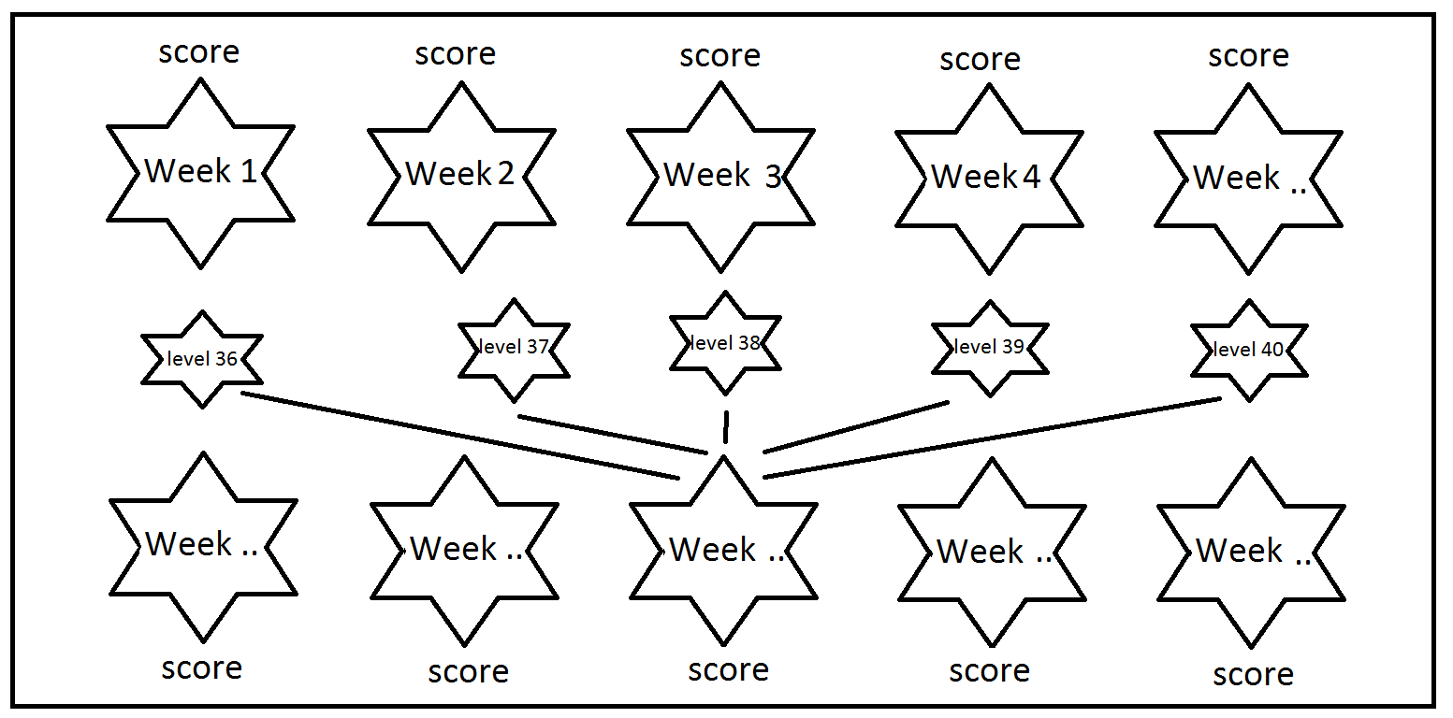

* Exit button (lower left corner of screen)

## Ranks & Levels

Each week the player will gain access to 5 levels. The levels that are unlocked for that specific week or are unavailable (as the player has not reached that week yet) are greyed out. The player can select any unlocked level to try and increase their score. The player can only progress to the next level if the specific mission of that level has been completed.

The game is based on the popular game of Candy crush. The player can make combinations of similar coloured icons on a squared playing field. There are 5 colours available in the game which resemble a category of the food groups, e.g.:

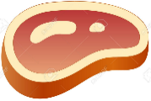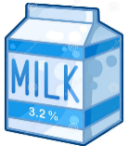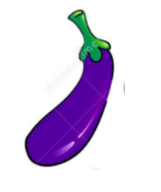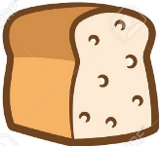

The player gets an ‘x’ amount of moves (s)he can make to reach a certain goal. The specific goal differs per level and ranges from getting to a threshold of points to deleting squares that are covered in fatty acid and to getting ingredients of recipes to the bottom of the page (the specific goals are stated under the ‘Levels’ section).

# General aspects of game

Before going into each week (or level) in detail, a number of generic elements to the game will be explained.

## Dashboard

## Points

The main primary aim of the game (from a user’s perspective) is to collect as many points as possible at the end of the intervention (week 10) by completing all the missions, while reaching all the levels.

* The players at the end of week 10 who have completed all levels will be placed in a draw to win a price.
* Each week players are eligible for prizes if they complete all levels

This way we can create incentive for the children to play the game, even when they are not into games. As the efficacy of our intervention depends on getting children to play the game, external incentives are deemed necessary.

Players can score points by making combinations of icons that belong to the same food group. They can do this by switching positions of adjacent icons around. This can result in points if they:

* Form a combination of 3 icons that belong to the same food group:
  + 100 points
* Form a combination of 4 that belong to the same food group:
  + 200 points
  + The original spot that gets switched and results in the formation of the combination turns into a ‘booster’
    - Booster (please refer to ‘icons’ section for description)
  + Clears row or column depending on the direction of the ‘switch’
* Form a combination of 5 of the same
  + 500 points
  + Special booster (please refer to ‘icons’ section for description)
    - The boosters form into food categories that are good for that specific body part (e.g. Omega-3-fatty acids for the brain)
  + Clears row and column
* Get boosters of all food groups per week
  + If the player collects a special boosters for all food groups during that week
  + 1000 points
  + Free special recipe
* Clear ingredients at bottom
  + 100 points per ingredient
  + Free recipe (matching the ingredients)
* Boosters
  + Boosters with normal icon
    - Normal boosters
      * 500 points
      * Health promotional message appears (see ‘health message’ section)
      * Clears row and column
        + Clears everything on field including plaque and other blockers
    - Special boosters
      * 500 points
      * Clears out all of the icons of the foodgroup the special item got switched with
        + E.g. if special icon switches with ‘fruit’-icon, than all fruit icon on the field disappear
      * Health promotional message appears (see ‘health message’ section)
  + Boosters with boosters
    - Normal boosters
      * 500 points
    - Special boosters
      * 500 points
      * Clears out all of the icons of the foodgroup the special item got switched with
        + E.g. if special icon switches with ‘fruit’-icon, than all fruit icon on the field disappear

## Boosters

### Normal boosters

When a player forms 4 items the spot that got switched turns into a normal booster. This normal booster gets a special glow around it, so it stands out. The specific design of the booster depends on the models we buy in Unity.

### Special boosters

When a player forms 5 items the spot that got switched turns into a special booster. The special booster is represented by a water bottle.

## Blockers

Unhealthy influences serve as blockers in the game. They prevent the user from making formations

* Plaque, fatty residu (model after Jelly in Candy Crush)
  + Needs to be cleared
* Junkfood (model after cupcakes in Candy Crush)
  + Junkfood covers up plaque or fatty residue
  + Eliminate them by making adjacent matches!
  + It takes 2 turns to get rid of junkfood
    - After the first turn, a health message should appear (see health messages section)
* Alcohol Bottles
  + Can only be cleared by special boosters
  + Will create a smoke if touched
* Smokes (modelled after chocolate in Candy crush)
  + Cannot be matched, and are resistant to special candy powers.
  + When touched will freeze screen for 3 seconds
  + Will respawn if no new row is cleared.

## Missions

The missions are similar per week but differ slightly in content. Each week, the games get a bit more difficult. The player is capable of replaying the games of the week to try and achieve a higher score.

Below a description of the goals per level per week are given as well as the specific lay-out the playing field needs to have. The layout of the field is modelled after Candy crush templates (specific template is mentioned in table).

### Week 1: the basics

The levels of the first week are designed to explain the main aims of the game.

|  |  |  |  |
| --- | --- | --- | --- |
|  | Goal | moves | Candycrush level layout |
| Level 1 | Reach 7000 points | 20 | Level 2 |
| Level 2 | Create one booster | 14 | Level 4 |
| Level 3 | Clear 3 ingredients | 15 | Level 1 |
| Level 4 | Create one special booster | 13 | Level 7 |
| Level 5 | Reach 7000 points in 20 seconds | unlimited | Level 3 |

### Week 2: introducing the bad guys

During the second week the bad influences get introduced

|  |  |  |  |
| --- | --- | --- | --- |
|  | Goal | moves | Candycrush level layout |
| Level 6 | Clear the fats* | 20 | Level 8 |
| Level 7 | Clear junkfood & fats | 34 | Level 4 |
| Level 8 | Clear the alcohol bottle | 15 | Level 1 |
| Level 9 | Clear the cigarettes | 13 | Level 7 |
| Level 10 | Clear smokes in 40 seconds | unlimited | Level 3 |

* fats represent various fatty deposits that you can find throughout your body when you live an unhealthy lifestyle. A specific explanatory message will be given in the level’s introduction

## Messages & Actions

In order to further enhance the ability of the game to influence attitudes specific messages will be sent to the user when (s)he is interacting with the game

### Level completed

If a player completes a level, the player receives positive information related to nutrition in combination with a summary of the score for that level. The playing field turns into the background and a banner appears at the middle of the screen. The banner features:

* Avatar
* Score
* Message
  + The message is related to the specific mission the player needs to complete
  + E.g. level 4 (create a special booster): “did you know that you should drink about 8 glasses of water a day to keep healthy?”

### Positive messages

Whenever a child scores points or does an action we want it to do (e.g. clear an alcohol bottle), it receives positive feedback. This feedback needs to appear at the same time of the action and is only visible for 1 second.

### Negative messages

If a player is not able to complete the level the player receives a health message related to the mission the player needs to complete:

* E.g. level 4 (create a special booster): “ not drinking enough water can increase the chance of spots”. Want to try again?

Furthermore, the game will give negative feedback in case the player touches a blocker

* E.g. touching a junkfood: “Bad move”
* E.g. clearing a smoke: “nasty”

This will be accompanied by negative stimuli such as buzzers.